**Smart Traffic Signal Optimization**

Bharath . D

192325064

CSA0959

Programming in Java for Scientific Applications

5. User Interaction

User Interface:

A user-friendly interface is crucial for traffic managers to monitor real-time traffic conditions and manually adjust signal timings if needed. The interface should include:

Dashboards: Visualize traffic data, signal timings, and historical data.

Control Panels: Allow manual adjustments to signal timings.

Documentation

Design Decisions:

Data Structures: Chosen to effectively represent traffic sensor data and intersections.

Algorithms: Designed to dynamically optimize traffic signals based on real-time data.

Assumptions: Assumed high reliability of traffic sensors and accurate data.

Potential Improvements:

Incorporate machine learning for predictive traffic flow optimization.

Improve sensor reliability and data accuracy.

Integrate with other smart city infrastructure (e.g., public transport schedules).

Testing

Test Cases:

Normal Traffic Conditions: Ensure the system optimizes signal timings correctly.

High Traffic Density: Verify the system extends green light duration for high-density directions.

Long Vehicle Queues: Confirm the system handles long queues by adjusting signal timings.

Pedestrian Crossings: Check the system activates pedestrian signals when needed.

**java final codes:**

import java.util.HashMap;

import java.util.Map;

import java.util.Scanner;

// Step 1: Define the IntersectionData class to hold sensor data

class IntersectionData {

private String intersectionID;

private String signalID;

private int queueLength;

private int averageSpeed;

public IntersectionData(String intersectionID, String signalID, int queueLength, int averageSpeed) {

this.intersectionID = intersectionID;

this.signalID = signalID;

this.queueLength = queueLength;

this.averageSpeed = averageSpeed;

}

public String getIntersectionID() {

return intersectionID;

}

public String getSignalID() {

return signalID;

}

public int getQueueLength() {

return queueLength;

}

public int getAverageSpeed() {

return averageSpeed;

}

@Override

public String toString() {

return "Intersection " + intersectionID + " - Signal " + signalID + " | Queue Length: " + queueLength + ", Average Speed: " + averageSpeed + " km/h";

}

}

// Step 2: Create a service to fetch real-time sensor data

class SensorDataService {

private Map<String, IntersectionData> dataMap;

public SensorDataService() {

this.dataMap = new HashMap<>();

}

public void addData(String intersectionID, IntersectionData data) {

dataMap.put(intersectionID, data);

}

public Map<String, IntersectionData> getRealTimeData() {

return dataMap;

}

}

// Step 3: Create a service to control signal timings

class SignalControlService {

public void updateSignalTiming(String signalID, int phaseDuration) {

System.out.println("Updating signal " + signalID + " with duration: " + phaseDuration + " seconds.");

}

}

// Step 4: Define the main TrafficSignalController class to optimize signals

class TrafficSignalController {

private SensorDataService sensorDataService;

private SignalControlService signalControlService;

public TrafficSignalController(SensorDataService sensorService, SignalControlService controlService) {

this.sensorDataService = sensorService;

this.signalControlService = controlService;

}

public void optimizeTrafficSignals() {

Map<String, IntersectionData> intersections = sensorDataService.getRealTimeData();

for (IntersectionData data : intersections.values()) {

int phaseDuration = calculateOptimalPhaseDuration(data);

signalControlService.updateSignalTiming(data.getSignalID(), phaseDuration);

}

}

private int calculateOptimalPhaseDuration(IntersectionData data) {

int queueLength = data.getQueueLength();

// Simple formula: phase duration is queue length divided by 2, within a range

return Math.max(30, Math.min(120, queueLength * 2));

}

public void displayTrafficConditions() {

for (IntersectionData data : sensorDataService.getRealTimeData().values()) {

System.out.println(data.toString());

}

}

public String generateReport() {

int totalQueueLength = 0;

int totalAverageSpeed = 0;

int count = 0;

for (IntersectionData data : sensorDataService.getRealTimeData().values()) {

totalQueueLength += data.getQueueLength();

totalAverageSpeed += data.getAverageSpeed();

count++;

}

double avgQueueLength = (double) totalQueueLength / count;

double avgSpeed = (double) totalAverageSpeed / count;

StringBuilder report = new StringBuilder();

report.append("Traffic Flow Report\n");

report.append("===================\n");

report.append("Average Queue Length: ").append(avgQueueLength).append("\n");

report.append("Average Speed: ").append(avgSpeed).append(" km/h\n");

return report.toString();

}

}

// Main class to run the program

public class TrafficManagementSystem {

public static void main(String[] args) {

// Instantiate services

SensorDataService sensorService = new SensorDataService();

SignalControlService controlService = new SignalControlService();

TrafficSignalController controller = new TrafficSignalController(sensorService, controlService);

// Get user input

Scanner scanner = new Scanner(System.in);

System.out.println("Enter the number of intersections:");

int numberOfIntersections = scanner.nextInt();

scanner.nextLine(); // Consume newline

for (int i = 0; i < numberOfIntersections; i++) {

System.out.println("Enter details for intersection " + (i + 1) + ":");

System.out.print("Intersection ID: ");

String intersectionID = scanner.nextLine();

System.out.print("Signal ID: ");

String signalID = scanner.nextLine();

System.out.print("Queue Length: ");

int queueLength = scanner.nextInt();

System.out.print("Average Speed: ");

int averageSpeed = scanner.nextInt();

scanner.nextLine(); // Consume newline

IntersectionData data = new IntersectionData(intersectionID, signalID, queueLength, averageSpeed);

sensorService.addData(intersectionID, data);

}

// Optimize traffic signals and display conditions

controller.optimizeTrafficSignals();

controller.displayTrafficConditions();

// Generate and display report

String report = controller.generateReport();

System.out.println(report);

}

}

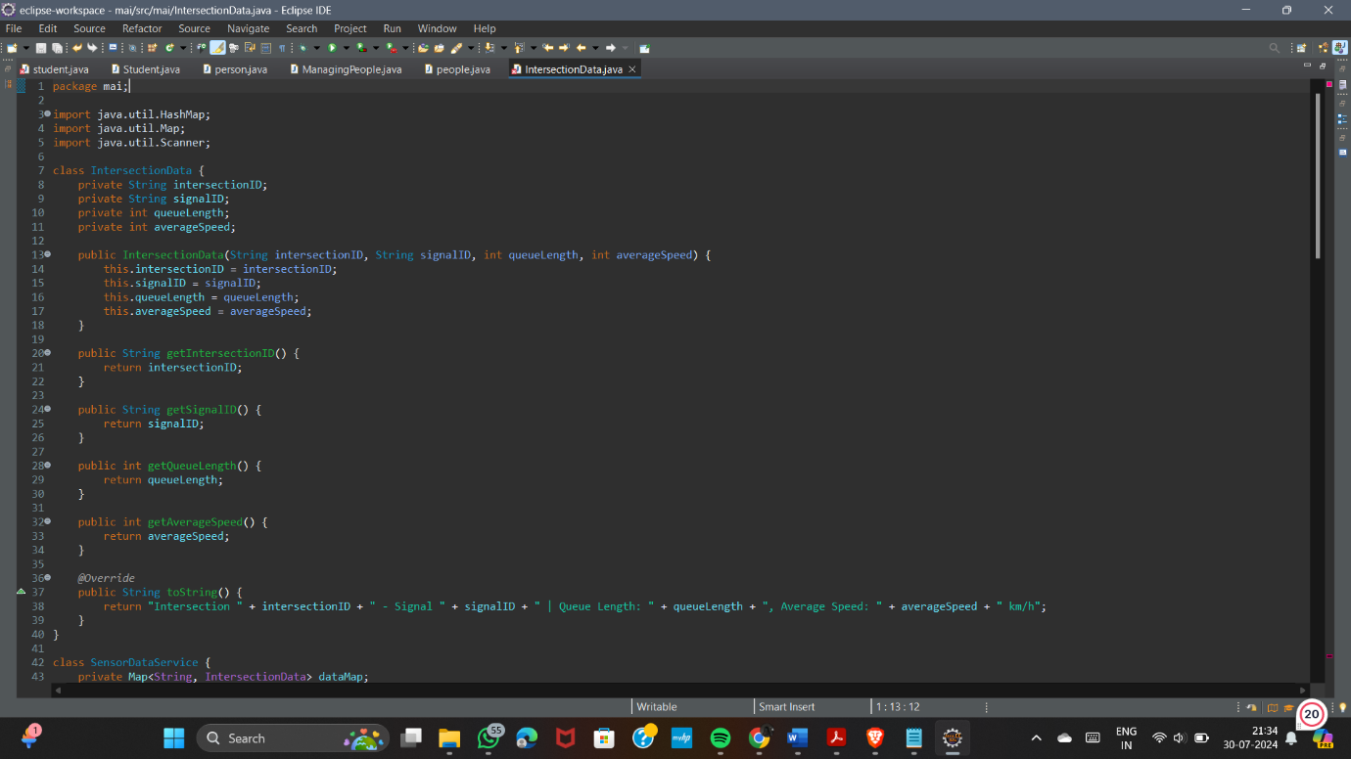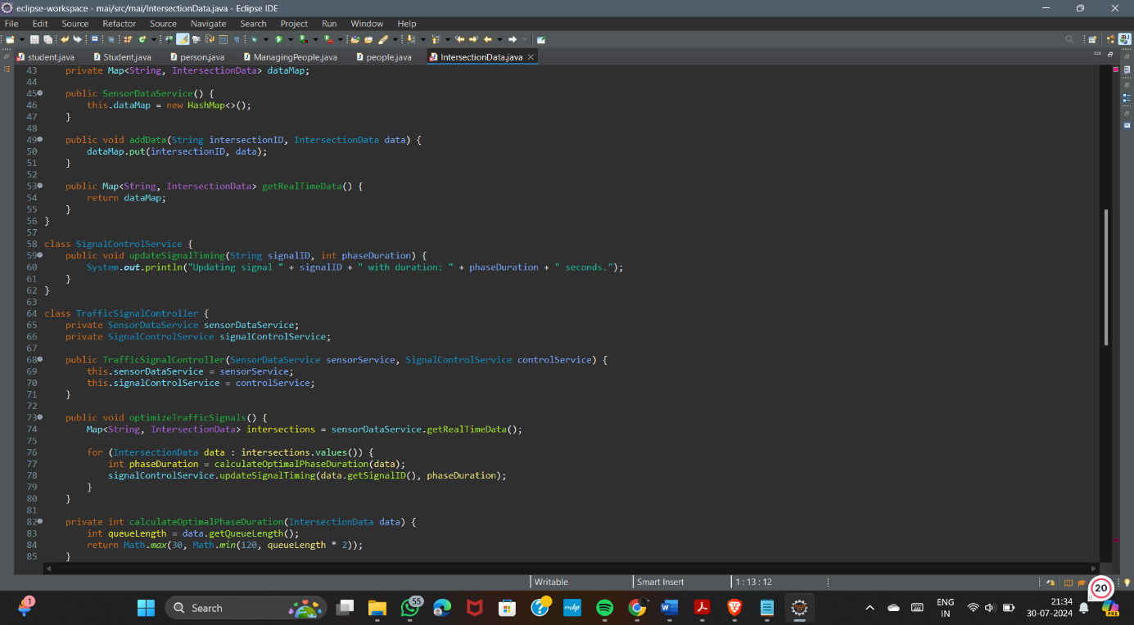

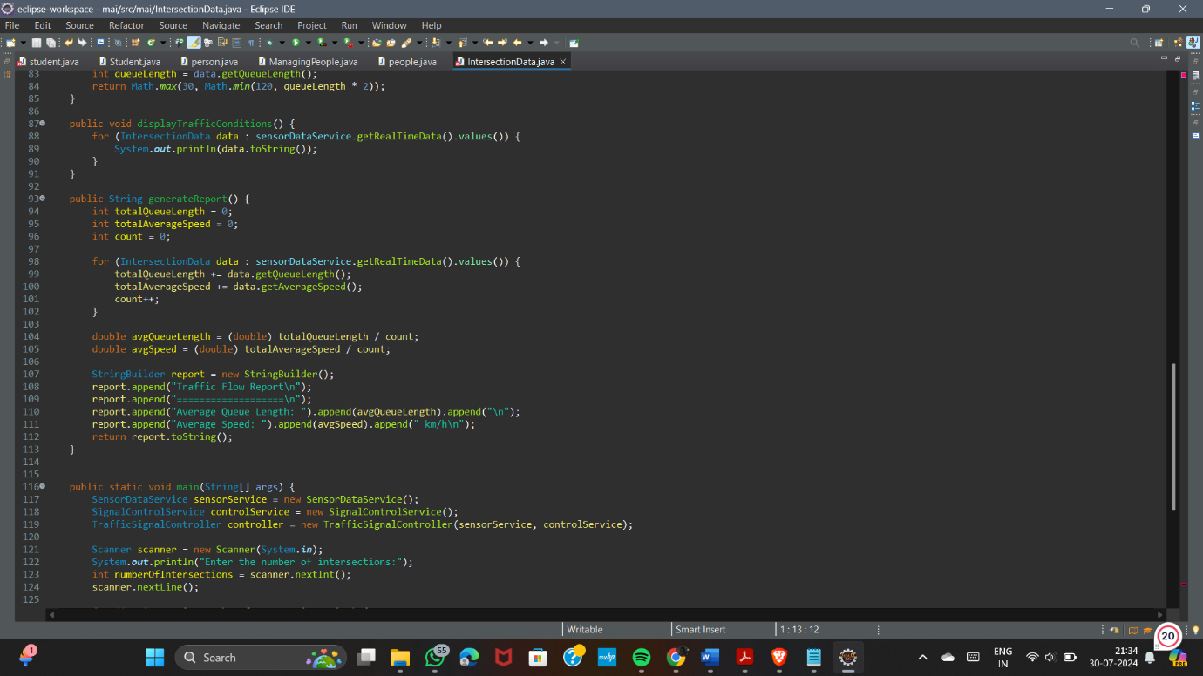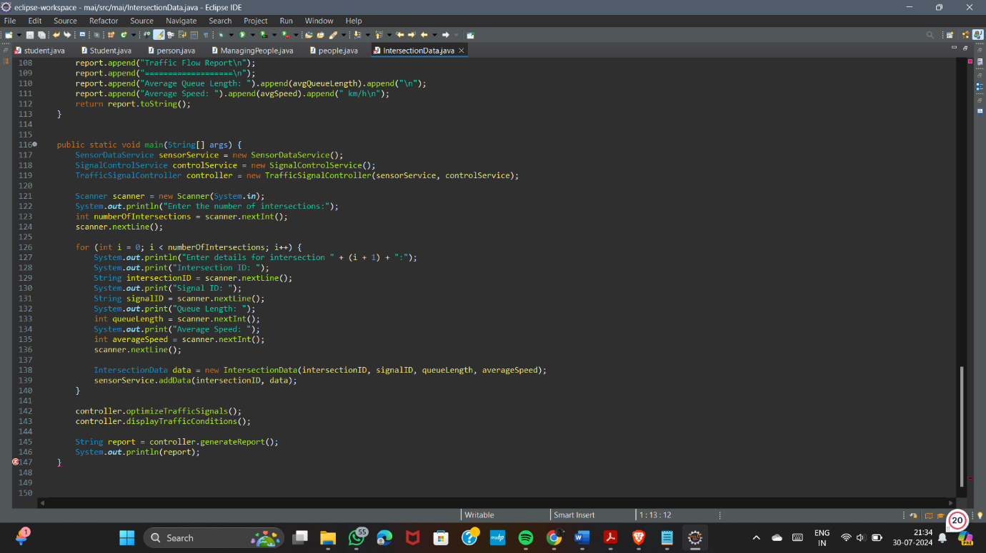

Output:

